**Sequence Diagram**

Sequence diagrams describe interactions among classes in terms of an exchange of messages over time.

**Basic Sequence Diagram Symbols and Notations**

**Class roles**

Class roles describe the way an object will behave in context. Use the UML object symbol to illustrate class roles, but don't list object attributes.

Class roles

**Activation**

Activation boxes represent the time an object needs to complete a task.

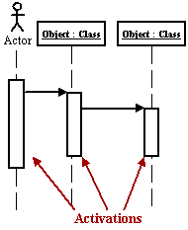

**Messages**

Messages are arrows that represent communication between objects. Use half-arrowed lines to represent asynchronous messages. Asynchronous messages are sent from an object that will not wait for a response from the receiver before continuing its tasks.

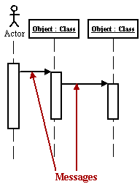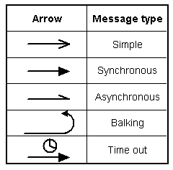  
*Various message types for Sequence and Collaboration diagrams*

**Lifelines**

Lifelines are vertical dashed lines that indicate the object's presence over time.

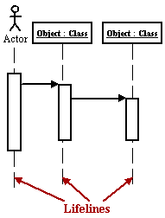

**Destroying Objects**

Objects can be terminated early using an arrow labeled "<< destroy >>" that points to an X.

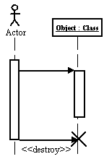

**Loops**

A repetition or loop within a sequence diagram is depicted as a rectangle. Place the condition for exiting the loop at the bottom left corner in square brackets.

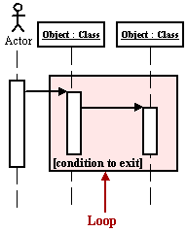

Admin Sequence diagram



Fig: Admin Sequence diagram

User Sequence Diagram

